LAB 4 -Report
Lint Schematics
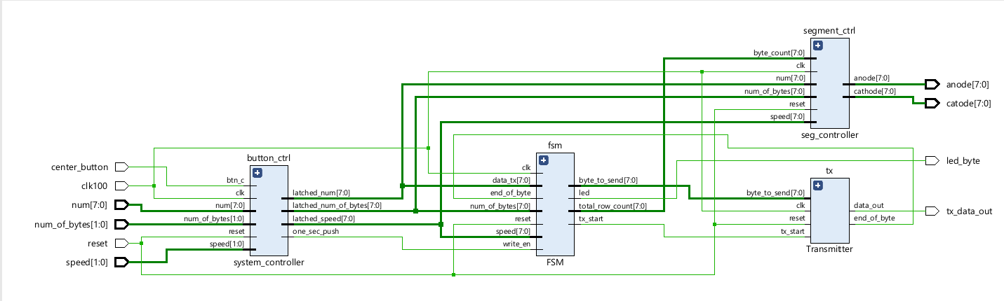
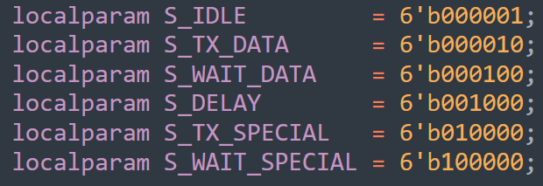
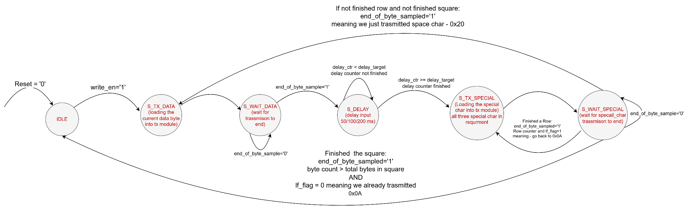
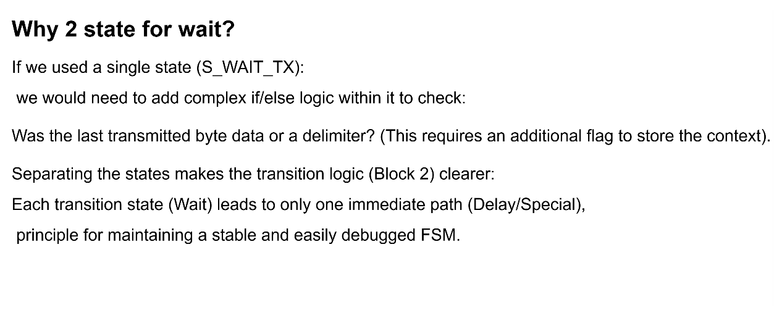
System State Machine - Diagram
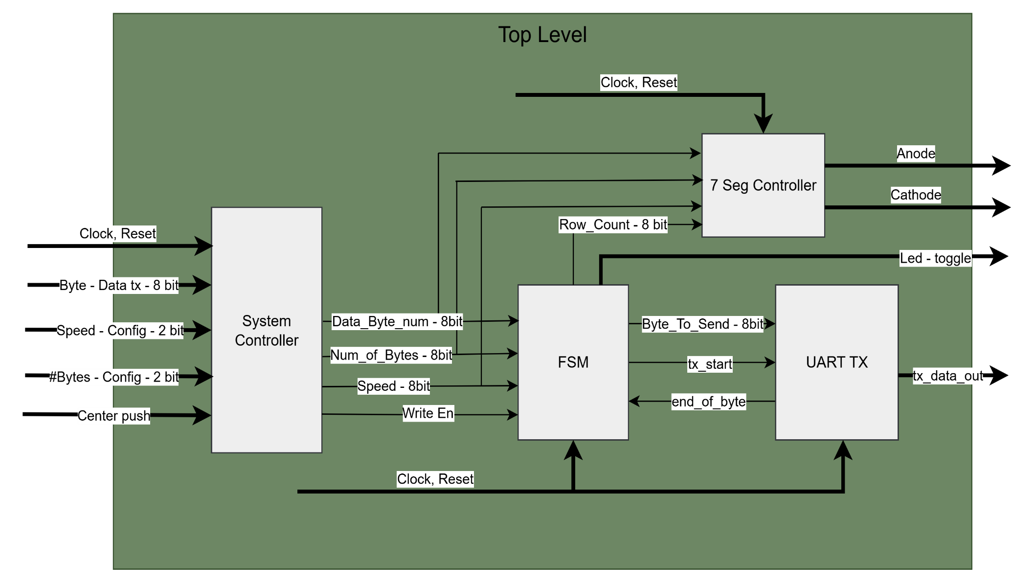
System Block - Diagram

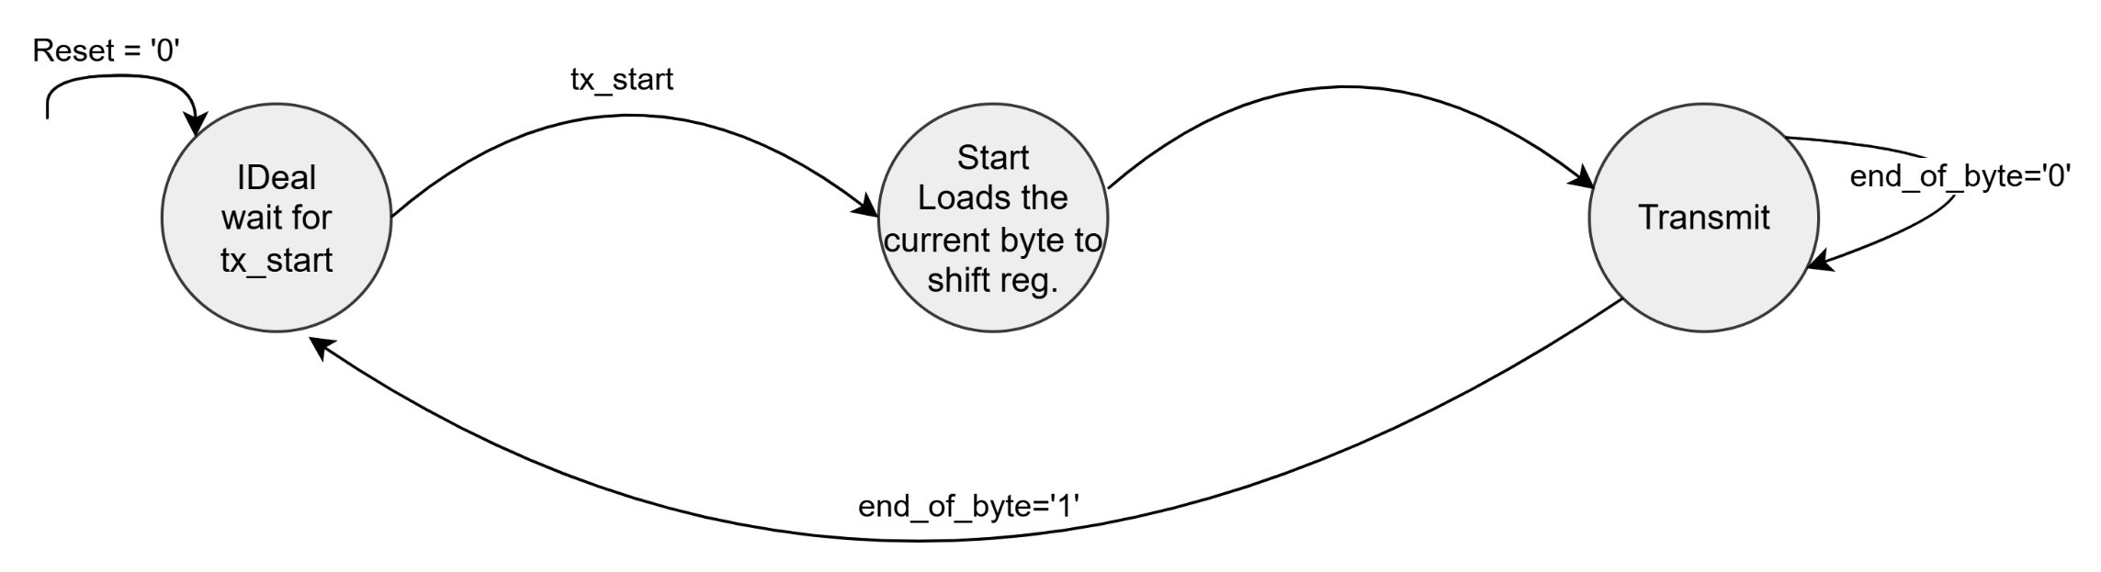
UATR Tx State Machine Diagram

Simulation waveform diagram
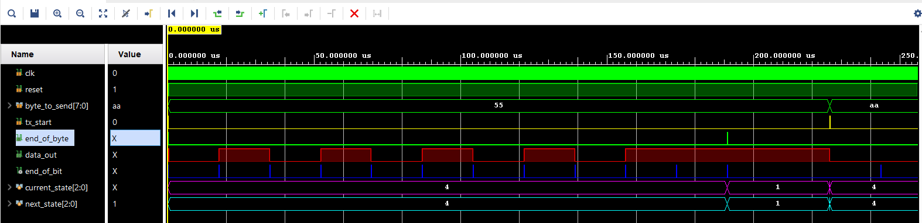
Transmitter:
Byte to send = 0x55 = 01010101
Data_out = {0[start_bit],
10101010 [0x55 LSB First],
1[stop bit],1[stopbit]}
End of bit = pulse every 1735 clk cycles and shift reg.
End of byte after 2 stop bits finished byte

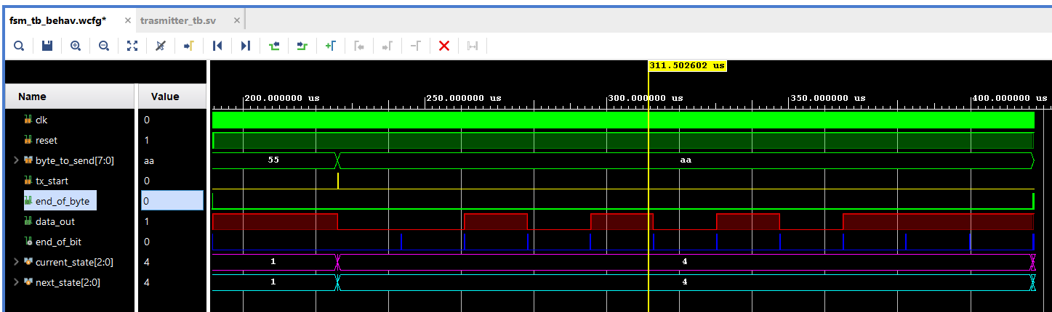
Data_out = {0[start_bit],
01010101[0xAA LSB First],
1[stop bit],1[stopbit]}
End of bit = pulse every 1735 clk cycles and shift reg.
End of byte after 2 stop bits finished byte
Byte to send = 0xaa = 10101010

Top level FSM (Master)
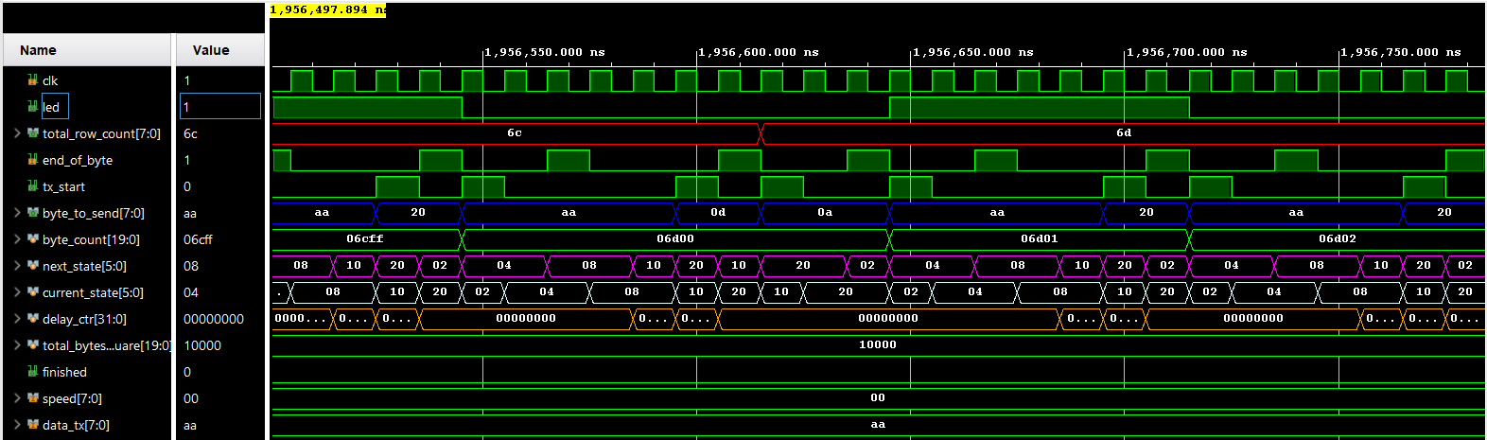
Row count
Byte to send: data->0x0D->0x0A->data
Total byte count
Next state: tx data (sending 0xAA) -> wait data (waiting of end of byte) -> delay (2 clk cycles – no delay) ->
Tx special (sending 0x0D) -> wait special (waiting of end of byte) -> tx special (sending 0x0A) -> wait special (waiting of end of byte) -> tx data (sending 0xAA) -> delay-> tx special (sending 0x20 – space char.) -> wait special
Delay counter: remains zero , and never raises as speed=0

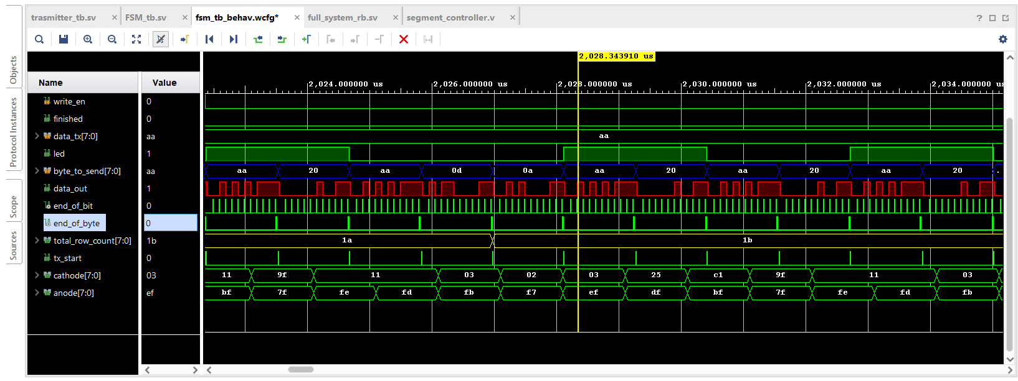
Full System modules
Data out – byte transmitted, LSB first, E.g.: 0xAA = {start-bit,0xAA, stop bit, Stop bit};
End of bit – end of bit counter reach 1735 clock cycles
Total-row-count – separate row counter (row_char_ctr) reaches the row width target (size from the num of bytes)
End of byte – every byte transmitted the tx sends the fsm signal it is available for next byte.
LED – Toggle every byte
Byte to send – 0xaa (data) -> 0x20 (space)
->0xaa (data)->0x0D (carriage return) -> 0x0A (new Line feed)

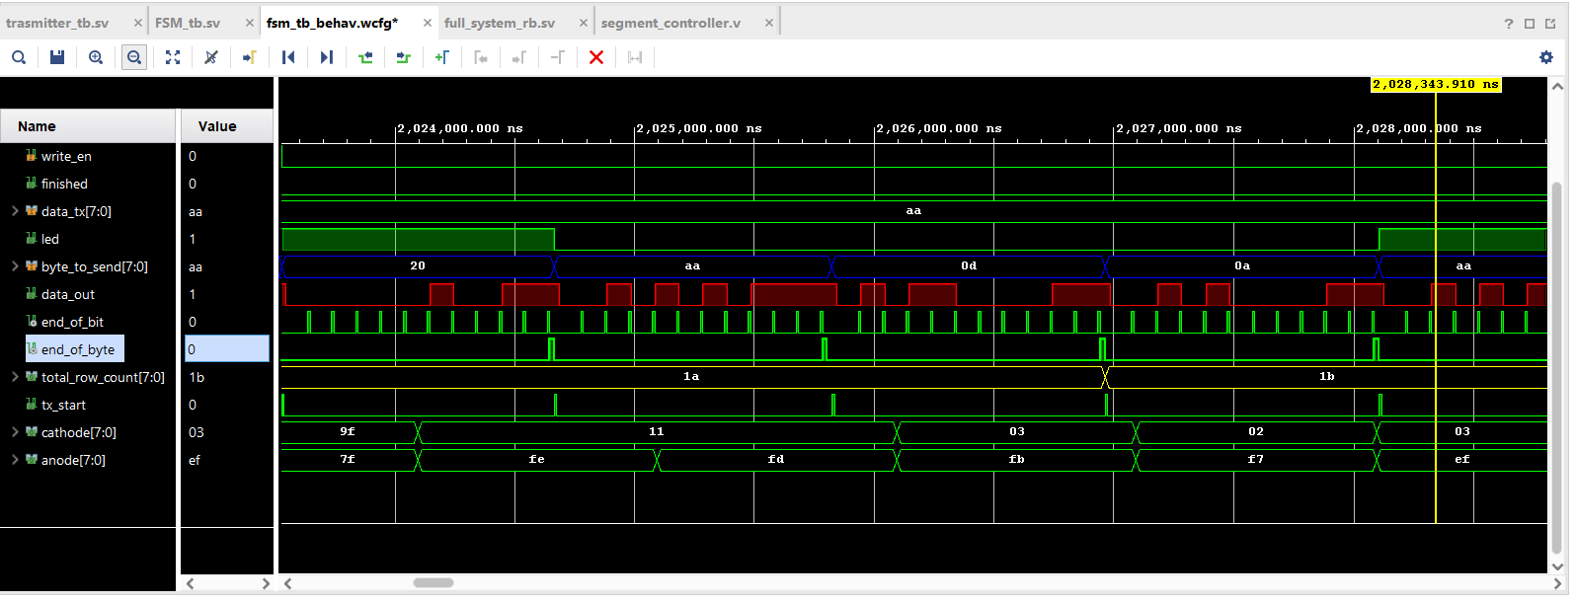
Zoom In

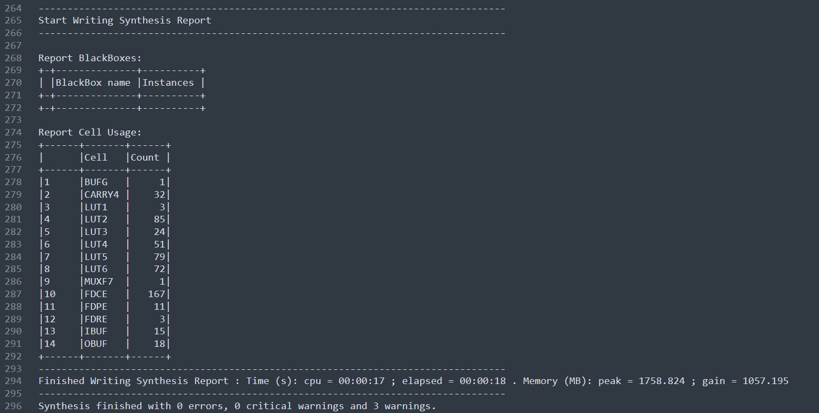
Synthesis Report

These are the major warning:
- WARNING: [Synth 8-10929] literal value 'd256 truncated to fit in 8 bits [C:/RTL_design/LAB4_NEW/LAB4_NEW.srcs/sources_1/imports/design/FSM.v:75] – that is fine we count from 0 up to 255 lines.
- WARNING: [Synth 8-327] inferring latch for variable 'finished_reg' [C:/RTL_design/LAB4_NEW/LAB4_NEW.srcs/sources_1/imports/design/FSM.v:110] – the finished variable was for simulation purposes only
- WARNING: [Synth 8-3332] Sequential element (fsm/finished_reg) is unused and will be removed from module top_level. – same as the previous warning.
- WARNING: [Synth 8-7080] Parallel synthesis criteria is not met -
probably because most of the hardware synthesized in the FSM module according to the design.
Successful Bitstream:
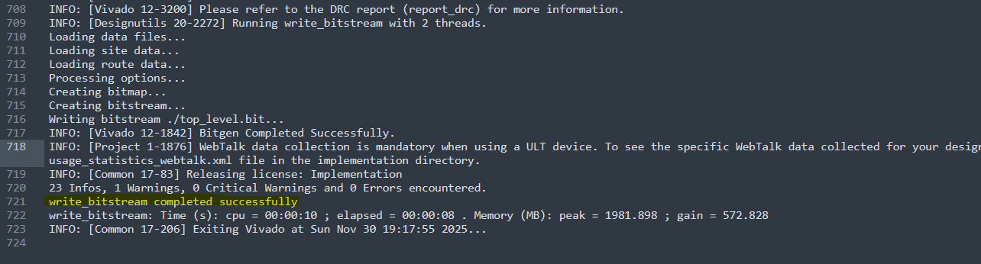

Validated bitstream

